Summary - Int 3, Group B, 𝚫𝚫G Version

Inbal Lorena Eshel

03/02/25

## Water

### Model 3P

| formula | R.sq | Q.sq | MAE |
| --- | --- | --- | --- |
| ddg ~ NPA_30 + diff_NBO_4_10 + Dist.10..8. | 0.745 | 0.645 | 0.314 |
| ddg ~ NPA_4 + NPA_30 + Dist.10..8. | 0.714 | 0.600 | 0.333 |

***Multicollinearity check***

|  | x |
| --- | --- |
| NPA_30 | 1.013 |
| diff_NBO_4_10 | 1.007 |
| Dist.10..8. | 1.006 |

***Scaled Coefficients:***

|  | Estimate | Std. Error | t value | Pr(>|t|) |
| --- | --- | --- | --- | --- |
| (Intercept) | 1.018 | 0.063 | 16.233 | 0.00e+00 |
| NPA_30 | 0.249 | 0.064 | 3.899 | 4.65e-04 |
| diff_NBO_4_10 | 0.355 | 0.064 | 5.555 | 3.90e-06 |
| Dist.10..8. | -0.427 | 0.064 | -6.700 | 1.00e-07 |

### Model 4P

| formula | R.sq | Q.sq | MAE |
| --- | --- | --- | --- |
| ddg ~ NPA_30 + diff_NBO_4_10 + diff_NBO_32_30 + Dist.10..8. | 0.804 | 0.703 | 0.283 |
| ddg ~ NPA_30 + NPA_32 + diff_NBO_4_10 + Dist.10..8. | 0.804 | 0.703 | 0.283 |

***Multicollinearity check***

|  | x |
| --- | --- |
| NPA_30 | 1.502 |
| diff_NBO_4_10 | 1.190 |
| diff_NBO_32_30 | 1.664 |
| Dist.10..8. | 1.078 |

***Scaled Coefficients:***

|  | Estimate | Std. Error | t value | Pr(>|t|) |
| --- | --- | --- | --- | --- |
| (Intercept) | 1.018 | 0.056 | 18.221 | 0.0000000 |
| NPA_30 | 0.370 | 0.069 | 5.335 | 0.0000082 |
| diff_NBO_4_10 | 0.428 | 0.062 | 6.933 | 0.0000001 |
| diff_NBO_32_30 | 0.223 | 0.073 | 3.052 | 0.0046319 |
| Dist.10..8. | -0.381 | 0.059 | -6.475 | 0.0000003 |

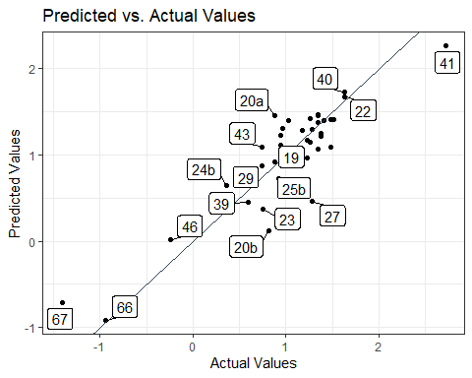

## Methanol

### Model 3P

| formula | R.sq | Q.sq | MAE |
| --- | --- | --- | --- |
| ddg ~ diff_NBO_4_10 + Dist.10..8. + B1_3_9 | 0.661 | 0.441 | 0.373 |
| ddg ~ NPA_4 + Dist.10..8. + B1_3_9 | 0.669 | 0.437 | 0.359 |

***Multicollinearity check***

|  | x |
| --- | --- |
| diff_NBO_4_10 | 1.079 |
| Dist.10..8. | 1.180 |
| B1_3_9 | 1.263 |

***Scaled Coefficients:***

|  | Estimate | Std. Error | t value | Pr(>|t|) |
| --- | --- | --- | --- | --- |
| (Intercept) | 1.018 | 0.072 | 14.086 | 0.0000000 |
| diff_NBO_4_10 | 0.248 | 0.076 | 3.264 | 0.0026183 |
| Dist.10..8. | -0.323 | 0.080 | -4.059 | 0.0002969 |
| B1_3_9 | -0.262 | 0.082 | -3.179 | 0.0032727 |

### Model 4P

| formula | R.sq | Q.sq | MAE |
| --- | --- | --- | --- |
| ddg ~ diff_NBO_4_10 + Dist.10..8. + Dist.10..7. + B1_3_9 | 0.721 | 0.520 | 0.345 |
| ddg ~ NPA_4 + Dist.10..8. + Dist.32..30. + B1_3_9 | 0.725 | 0.495 | 0.338 |

***Multicollinearity check***

|  | x |
| --- | --- |
| diff_NBO_4_10 | 1.161 |
| Dist.10..8. | 1.258 |
| Dist.10..7. | 1.169 |
| B1_3_9 | 1.263 |

***Scaled Coefficients:***

|  | Estimate | Std. Error | t value | Pr(>|t|) |
| --- | --- | --- | --- | --- |
| (Intercept) | 1.018 | 0.067 | 15.286 | 0.0000000 |
| diff_NBO_4_10 | 0.298 | 0.073 | 4.102 | 0.0002752 |
| Dist.10..8. | -0.372 | 0.076 | -4.910 | 0.0000278 |
| Dist.10..7. | 0.189 | 0.073 | 2.585 | 0.0146537 |
| B1_3_9 | -0.265 | 0.076 | -3.489 | 0.0014778 |

